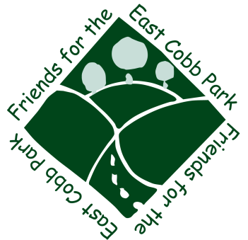

2014 Friends for the East Cobb Park
Holiday Lights Celebration Sponsorship Form

Contact: Amber Harris, Holiday Lights Chairperson and President, Friends for the East Cobb Park
770-309-3196 email: amberjeanharris@hotmail.com
Event Date: Sunday, December 7th, 2014 at 5 p.m.

Sponsor Name
Contact person for business/organization
Address
City State Zip
Phone Fax
Email

- Presenting Sponsorship ($1000)
  - Sponsor may display approved promotional sign no larger than 18x24 on the Park’s bulletin board continuously during the month of December regarding their sponsorship (please submit design to Amber Harris for approval)
  - 2 minute introduction/presentation on stage will be provided at the start of the event at 5 p.m.
  - Sponsor may display a promotional banner or sign in Park all day on the day of the event
  - Presenting sponsors will be allowed to jointly light the star
  - Flyer announcements will be distributed to local schools, businesses, groups, etc.
  - Name recognition will be provided on our website (www.eastcobbpark.org) and banners
  - Two (2) Reserved Parking Spots.
- Gold Sponsorship ($500)
  - Shared custom logo banner with other gold sponsors will be displayed at event
  - Flyer announcements will be distributed to local schools, businesses, groups, etc.
  - Name recognition will be provided on our website (www.eastcobbpark.org) and banners
  - Sponsor may display a promotional banner or sign in Park all day on the day of the event
  - One (1) reserved parking spot
- For Silver Sponsorship ($250)
  - Sponsor may display a promotional banner or sign in Park all day on the day of the event
  - Shared custom banner with other silver sponsors will be displayed at the event
  - Flyer announcements will be distributed to local schools, businesses, groups, etc.
  - Name recognition will be provided on our website (www.eastcobbpark.org) and banners

- For Bronze Sponsorship ($150)
  - Shared custom banner with other bronze sponsors will be displayed at the event
  - Flyer announcements will be distributed to local schools, businesses, groups, etc.
  - Name recognition will provided on our website (www.eastcobbpark.org) and banners

- For Food Sponsorship – Please contact me directly for more info

- For Homeowners Association Sponsorship (Suggested amount $1 per home)
  - Name recognition on website (www.eastcobbpark.org) and banners

- For Friends and Family Sponsorship (Any amount)
  - Name recognition on website (www.eastcobbpark.org) and banners

Checks can be made payable to: Friends for the East Cobb Park, and mailed to: Attn: Amber Harris- Friends for the East Cobb Park P.O. Box 6313, Marietta, GA 30065. Contributions are tax-deductible, as Friends for the East Cobb Park is a non-profit 501(c)3 tax-exempt organization.
Sponsors may not sell items for profit. Any items to be sold must be approved by the Holiday Lights Chairperson. All proceeds from any sales must go to the Friends for the East Cobb Park.

Sponsor Signature:
Date: ___ / ___ / ___

Friends for the East Cobb Park Rep. Signature:
Date: ___ / ___ / ___

